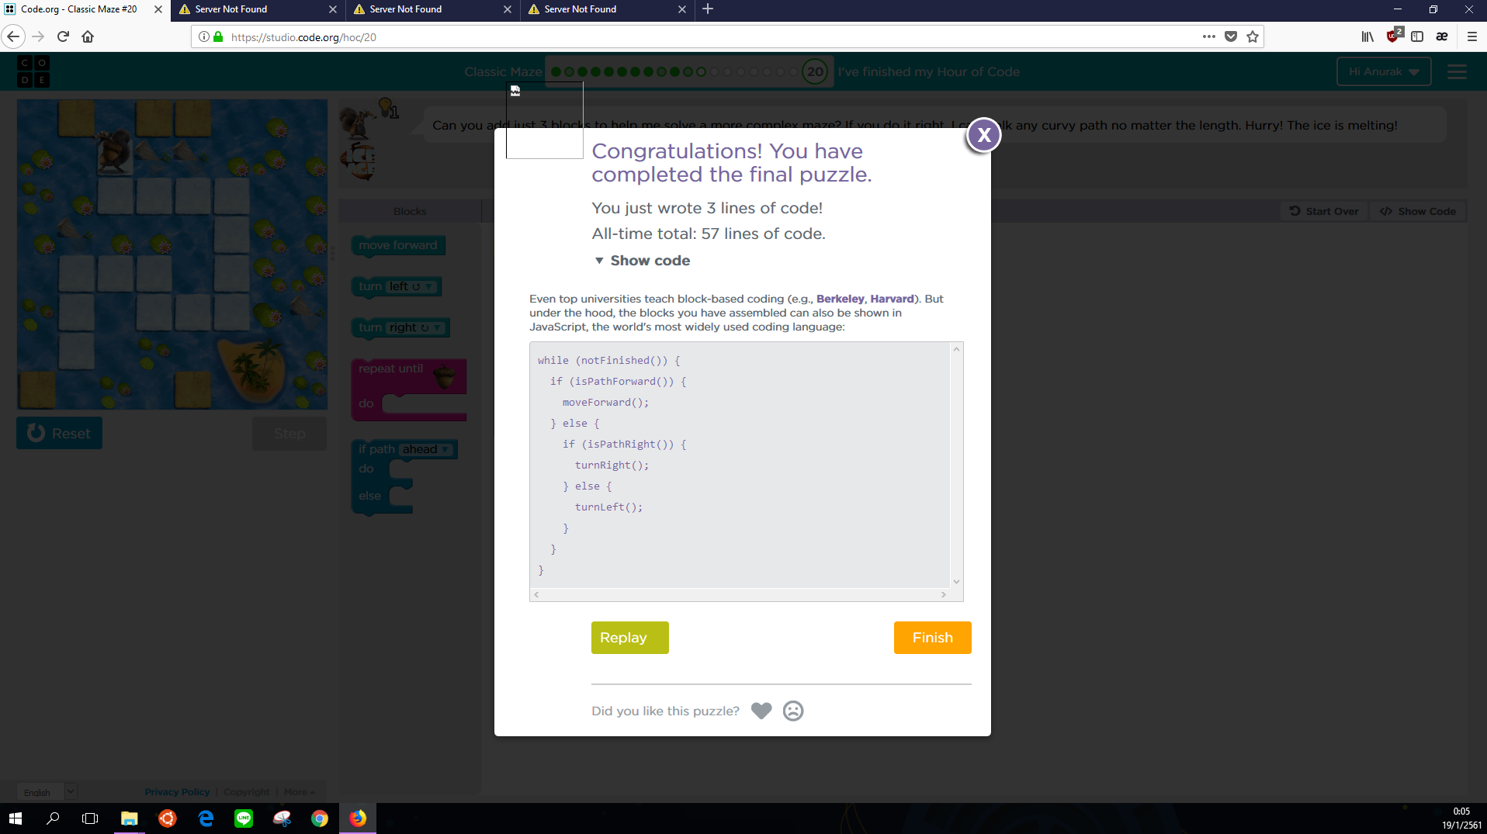

**while (notFinished()) {**

**if (isPathForward()) {**

**moveForward();**

**} else {**

**if (isPathRight()) {**

**turnRight();**

**} else {**

**turnLeft();**

**}**

**}**

**}**